Critical link between **Activity/Task 3.2** and other activities/tasks within Component 3 and other components of T&I Project:

|  |  |
| --- | --- |
| *RELATIONSHIP TO OTHER TASKS* | Informed by Task 3.1  The review process from Task 3.1 helps identify knowledge gaps for which further study is conducted via Task 3.2 regarding major food sources for key species with information gaps.  Inform and link to Task 3.3  Results from diet study via Task 3.2, along with existing knowledge and data from Task 3.1 inform Task 3.3 regarding the focus of research on key food sources for fish and waterbirds. Task 3.3 fieldwork also provides samples for diet study particularly from fish sampling.  Inform Task 3.4  The findings from Task 3.2 will fill key knowledge gaps regarding major food sources and their relative importance, which will inform quantitative food web model development. |
| *RELATIONSHIP TO OTHER HCHB PROJECTS* | -Link to T&I Component 4 ‘Maintaining viable waterbird populations’  Project 4 will provide scat samples for waterbird diet study in Task 3.2.  Information about the food intake of key waterbird species will come from Project 4.  Data and findings from Task 3.2 regarding important food sources will be shared with Project 4. |

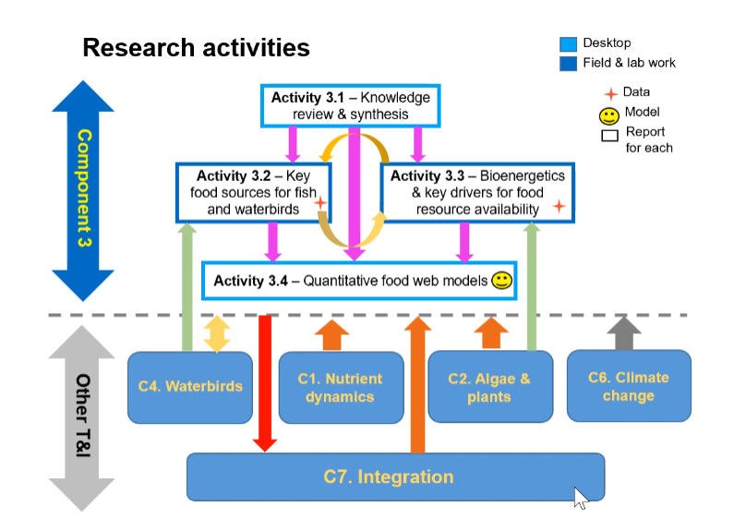

Figure 1. How Component 3 activities link to other HCHB Trials and Investigations components.